PL/SQL
Exercise 3:
BEGIN
EXECUTE IMMEDIATE 'DROP TABLE ACCOUNTS';
EXCEPTION
WHEN OTHERS THEN
IF SQLCODE != -942 THEN -- ORA-00942: table does not exist
RAISE;
END IF;
END;
/
CREATE TABLE ACCOUNTS (
AccountID NUMBER PRIMARY KEY,
CustomerID NUMBER,
AccountType VARCHAR2(20),
Balance NUMBER
);

INSERT INTO ACCOUNTS VALUES (101, 1, 'SAVINGS', 1000);
INSERT INTO ACCOUNTS VALUES (102, 1, 'CHECKING', 500);
INSERT INTO ACCOUNTS VALUES (103, 2, 'SAVINGS', 3000);
INSERT INTO ACCOUNTS VALUES (104, 3, 'SAVINGS', 700);
COMMIT;
------------------------
Scenario 1:
CREATE OR REPLACE PROCEDURE ProcessMonthlyInterest IS
BEGIN
UPDATE ACCOUNTS
SET Balance = Balance + (Balance * 0.01)
WHERE UPPER(AccountType) = 'SAVINGS';

DBMS_OUTPUT.PUT_LINE(SQL%ROWCOUNT || ' savings accounts updated with interest.');

COMMIT;
END;
/

BEGIN
DBMS_OUTPUT.ENABLE;
END;
/

BEGIN
ProcessMonthlyInterest;
END;
/
Scenario 3
CREATE OR REPLACE PROCEDURE TransferFunds (
p_FromAccountID IN NUMBER,
p_ToAccountID IN NUMBER,
p_Amount IN NUMBER
) IS
v_FromBalance NUMBER;
BEGIN
SELECT Balance INTO v_FromBalance
FROM ACCOUNTS
WHERE AccountID = p_FromAccountID
FOR UPDATE;

IF v_FromBalance < p_Amount THEN
RAISE_APPLICATION_ERROR(-20001, 'Insufficient balance in source account.');
END IF;

UPDATE ACCOUNTS
SET Balance = Balance - p_Amount
WHERE AccountID = p_FromAccountID;

UPDATE ACCOUNTS
SET Balance = Balance + p_Amount
WHERE AccountID = p_ToAccountID;

DBMS_OUTPUT.PUT_LINE('Transferred ' || p_Amount || ' from account ' || p_FromAccountID || ' to account ' || p_ToAccountID);

COMMIT;
END;
/
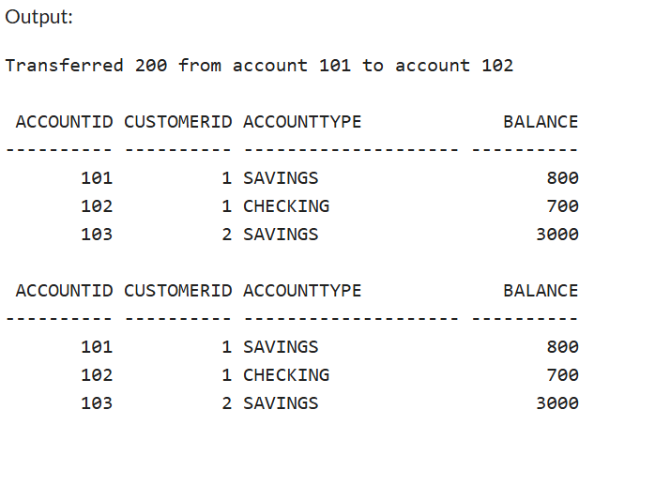
Scenario 2:
CREATE OR REPLACE PROCEDURE UpdateEmployeeBonus (
p_DepartmentID IN NUMBER,
p_BonusPercent IN NUMBER
) IS
BEGIN
UPDATE EMPLOYEES
SET Salary = Salary + (Salary * p_BonusPercent / 100)
WHERE DepartmentID = p_DepartmentID;

DBMS_OUTPUT.PUT_LINE(SQL%ROWCOUNT || ' employee(s) updated with a ' || p_BonusPercent || '% bonus.');

COMMIT;
END;
/

